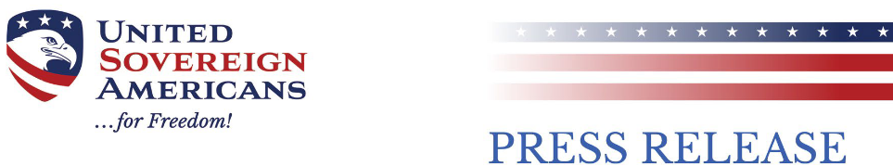

**AUGUST 8, 2024**

Citizens Group Demands State Correct Errors  
in Voter Registration Database

**HELENA, Montana** - United Sovereign Americans (USA) filed a report on August 5, 2024, with the Montana Secretary of State regarding what appear to be serious breaches of statutory standards on both the Federal and state level meant to ensure the reliability of federal elections. In some cases, hundreds of thousands of potential voter irregularity/registration cases would either need to be explained or classified as illegal votes, obviously affecting 1) compliance with Federal and state vote procedure requirements; 2) reflecting election results certified as legal but which in fact were illegal; and 3) reflecting possible election fraud in Montana during the 2022 general election and the 2024 primary election.

“USA is hoping to find a state that will work together with us to examine these issues thoroughly,” stated CEO Marly Hornik. Hornik continued “Montana would be a great partner. Our analysis shows that the state’s recent election software upgrade has significantly reduced voter roll accuracy. It’s not too late to act to recover the great effort put in by registrars for so many years.”

USA, a non-partisan election validity nonprofit, requests that the factual anomalies are investigated and satisfactorily explained. Citizens in Montana have raised these issues repeatedly and received little meaningful response. While USA does not claim to know who is responsible for these anomalies or why they exist, Secretary of State Christi Jacobsen has to date failed to substantially investigate the findings, and has certified election results contrary to standards set by the US Congress for error, accuracy, and compliance. The risk to all Montana citizens, if this dismissive attitude continues, is denial of the Constitutional guarantee to choose their representatives in accurate, legally reliable elections.

USA is not asking to overturn any particular election result. The report is intended to point out what may be recent or ongoing unreliable procedures, and a failure to follow the law in elections in Montana.

Professional auditors volunteering with USA exposed 105,137 apparent voter registration violations including duplicate voter records, voters missing required data elements like birthdates or full names, voters who have moved out of state or are deceased, and obviously inaccurate voter registration dates. The complaint also states that there were 72,571 apparent voting violations, including 48,583 votes counted from voters with back-dated registration dates, and 1095 votes added post certification, which could constitute editing federal election records without scrutiny. Federal law allowed for 4 errors in counting ballots in Montana’s 2022 midterm.

USA has filed federal lawsuits against state and federal officials who have thus far refused to protect the voting rights of their constituents, willingly counting votes of invalid and ineligible registrants equally to valid voters, a civil rights abridgment known as “dilution of the vote.” These actions have been filed in Maryland, Pennsylvania and Ohio, to date.

For additional information, please contact United Sovereign Americans at info@unite4freedom.com.

